

  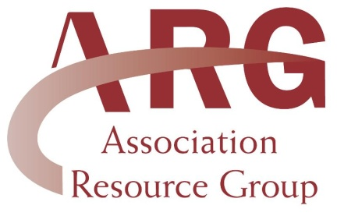
  ARG
  13790 E. Rice Place, #100
  Aurora, CO 80015
  303-693-0133
  lori@associationresource.net
  www.associationresource.net
  Don't forget to send me your upcoming events. I will put them on our home page and on our calendar page to promote your club!! Send all events to:
  lori@associationresource.net
  ARG Benefit Providers
  Equisure
  VPI Pet Insurance
  Hertz
  Hotels.com
  Horse Saddle Shop
  Office Depot
  PetsMart
  Sheplers
  1-800-Petmeds
  Dear ARG Members,
  I am excited to announce that we have a new benefit provider for ARG members....Constant Contact. Constant Contact is an email marketing company that can help you streamline your communication with your members.
  Are you still sending out a newsletter on paper and mailing it? Do you wonder how to send those beautiful email newsletters with links and pictures? Do you have a large volume of email addresses that you would like to store and manage in one place? Do you have a need to survey your members?
  If you answered yes to any of the above, then Constant Contact is a good fit for you. For as little as $15.00 per month, you can send out newsletters, surveys and information to your members via email. At that price, you can only send 35 newsletters through the postal service! You can manage and store all your email contacts in one place and your members can modify or update their own email in your system. Best of all, Constant Contact gives you feedback on the email communication you send out, such as who has opened your email, did anyone click through on your links, or did you have any email addresses that were not valid.
  Even better yet, Constant Contact is giving ARG members a discount on their services! You can try Constant Contact's services free on a 60 day trial. After that, you can sign up for your own account and receive the ARG discount. Constant Contact gives ARG members a 20% discount on a 6-month subscription and a 25% discount on a 1-year subscription.
  Do you like this email from ARG? I am using Constant Contact, and you can too. To get started, click on the link below. Remember, you can begin with a free 60 day trial!!
  http://www.constantcontact.com/index.jsp?pn=associationresource
  Sincerely,
  Lori Hampton
  ARG

