

  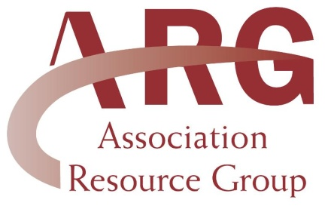
  ARG
  13790 E. Rice Place, #100
  Aurora, CO 80015
  303-693-0133
  lori@associationresource.net
  www.associationresource.net
  ______________________
  Member Benefit Highlight:
  1-800-Petmeds
  America's largest pet pharmacy. Get medication delivered right to your door at really low prices! Just like your veterinarian, Petmeds provides only U.S. FDA/EPA approved medications. Petmeds also offers a 100% satisfaction guarantee. The best part is that Pedmeds gives ARG members an additional 10% off their order!
  To take advantage of this discount, simply go to
  our website at www.associationresource.net and click on the "Member Benefits" tab. Once on the Members Benefit page, click on the
  1-800-Petmeds link to begin. Your 10% discount will show up in your cart when you are ready to purchase.
  ____________________________________
  What's Going on?
  September 2-5 - Ellensburg Rodeo in Ellensburg, WA
  September 3 - NATRC Region Five Benefit
  September 9-19 - Utah State Fair
  September 10 - Rockie Mountain Saddle Club show in Wellington, CO
  September 10 - NATRC - Chile Line, Region Four Benefit, Ride the Edge
  September 10-11 - Buxmont Riding CLub Horse Show in
  September 11 - Clark Co. Saddle Fun Show in Winchester, KY
  September 17 - NATRC - Oakland Hills Region One Benefit
  September 18 - CT Color Breed Horse Show #4 in Wolcott, CT
  To find out more about these and other events, visit our website at:
  www.associationresource.net
  Hello ARG Members,
  Summer isn't over yet! Check out our calendar of events...September is shaping up to be one busy month! The Utah State Fair runs September 8-18 in Salt Lake City. There is plenty of fun, food and of course great entertainment. To find out more about the Fair, visit www.utah-state-fair.com.
  It looks like our members will be busy with horse shows and competitions throughout the fall and into November. Wrapping up the November shows is Equine Affaire, held in W. Springfield, MA on November 10-13. Equine Affaire is one of the largest equine expositions and equestrian gatherings. For more information on the great educational programs presented at Equine Affaire, visit www.equineaffaire.com.
  ____________________________________
  Things to Remember
  - Send in your dues as soon as you receive your invoice to avoid any lapse in membership
  - Members with Personal Excess policies - your monthly member reports are due on the 15th of each month and the premium due the by 20th of each month
  - Check out the ARG website for new member benefits, news and more
  - Submit your events to be added to our online calendar of events.
  _________________________________________________
  Welcome to our Newest ARG Members
  Heaven Bound Cowboy Church
  Kids Junior Rodeo Association
  Kit Carson Riding Club
  Lake County Mounted Posse
  Lehigh Riding Club
  North Florida Paso Fino Asscociation
  Ultimate Horseman's Challenge
  Foxhorn Horse Shows
  Country Cowboy Church
  Exceptional Riders Program
  KyoveMorgan Horse Association
  Rush Springs Ranch
  Serenity Farms
  Top Horse Solutions
  KB Dressage
  Bay Area Dressage
  Wisconsin Horse Council
  High Plains Paint Horse Club
  Rising Star Equestrian Association
  Western Dressage Association of America
  Wheeler Saddle Club

