

  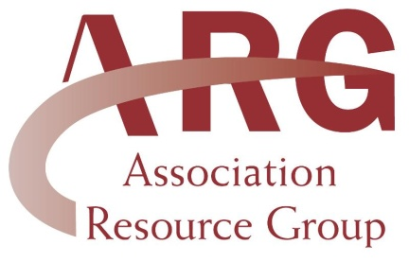
  ARG
  13790 E. Rice Place, #100
  Aurora, CO 80015
  303-693-0133
  lori@associationresource.net
  www.associationresource.net
  ______________________
  Don't forget about all your
  wonderful benefits as a member
  of ARG. We recently added
  Constant Contact as a benefit provider. Constant Contact is
  an email marketing company
  that lets you send newsletters
  and information to your members via email. It's a great way to communicate with your members as well as a database to keep member information and email addresses. You can even try their services free for 60 days. ARG members receive a 20% discount on a 6-month subscription or a 25% discount on a 1-year subscription. Click on the link below to find out
  more and receive your discount!
  http://www.constantcontact.com/index.jsp?pn=associationresource
  _______________________________________
  Check out our Message Boards!
  Do you need advice, want to ask a question or have a great tip? Then try out our new message board. Go to www.associationresource.net and click the "Message Board" tab.
  Our goal this year is to have a thriving community of members giving and receiving valuable information across our message board.
  Try it out today!
  Hello ARG Members,
  As the weather warms up, so does our event calendar. Our members are very busy this summer with dressage
  shows, schooling clinics, trail rides and conferences.
  Please take a minute to check out our Calendar of Events
  on our website. If you would like to add your events to our calendar, please email them to: lori@associationresource.net.
  ____________________________________
  Member Club Highlight: CT Color Breed
  CT Color Breed Association was founded by
  Nicole Souza in November 2010. Paperwork has been
  filed and we are in the process of becoming a
  non profit organization. CT Color Breed Association
  is open to all. CT Color Breed Association was
  created to provide a club in Connecticut strictly
  for color breed horses included but not limited to
  Palominos, Paints, Pintos, Appaloosas, Buckskins,
  and breeding stock/solid paints and pintos. There
  is no other club in Connecticut like this. We offer
  education clinics and horses shows for people who
  own color breed horses. Our goal and mission
  is to showcase color breed horses, promote an interest
  in color breed horses, educate people on the different
  color breeds, and generate more sales for color breed
  horses. For more information or questions please
  feel free to email ctcolorbreed@yahoo.com or check
  out us out on facebook under "Connecticut Color
  Breed". Our website is pending.
  ____________________________________________
  Upcoming Events for May
  North American Trail Ride Conference
  Rockie Mountain Saddle Club -
  English/Western/Gymkhana
  Utah All Breed Horse Association -
  Kathy Dorius Spring Classic
  Buxmont Riding Club -
  Western/Gymkhana/English/Driving
  Alaska State Quarter Horse Association -
  Tough Enough to Wear Pink
  CT Color Breed -
  Western Pleasure/Horsemanship Clinic
  More information on all upcoming events can be
  found on our website at:
  www.associationresource.net under our
  Calendar of Events

